**Name:** Nagaraju  **Emp.ID:** 213495

# Assessment: Add a connection to Azure SQL Database

Contents

Assessment: Add a connection to Azure SQL Database 1

Steps: 1

1) Create Azure SQL Database 1

2) Prerequisites 3

3) Connect to Azure SQL Database using Connected Services 5

Figure 1: Created Azure Storage Account to Create SQL Database 2

Figure 2: Creating SQL Database in Azure 3

Figure 3: Created SQL database in Azure 4

Figure 4: Set the firewall rule to the database 4

Figure 5: Creating Azure Functions project in Visual Studio 5

Figure 6: Assigning name to the Project 5

Figure 7: NewFunctions named project got created in VS 6

Figure 8: Adding connected Service to the Project 6

Figure 9: Adding existing database connection 7

Figure 10: Adding Azure Database dependency 7

Figure 11: Sign in to the existing Azure account 8

Figure 12: Displayed the existing database and created new database 8

Figure 13: New database creation from visual studio 9

Figure 14: NewFunctions_db database got created 9

Figure 15: Configuring Database by adding database connection credentials 10

Figure 16: Displayed summary of changes 10

Figure 17: Given the permissions to update the firewall rule 11

Figure 18: Azure database connection configuration status 11

Figure 19: Database configured to the visual studio 12

## Steps:

## Create Azure SQL Database

* Created Azure Storage account and login with Credentials.
* Tap on SQL Databases from dashboard to create database.

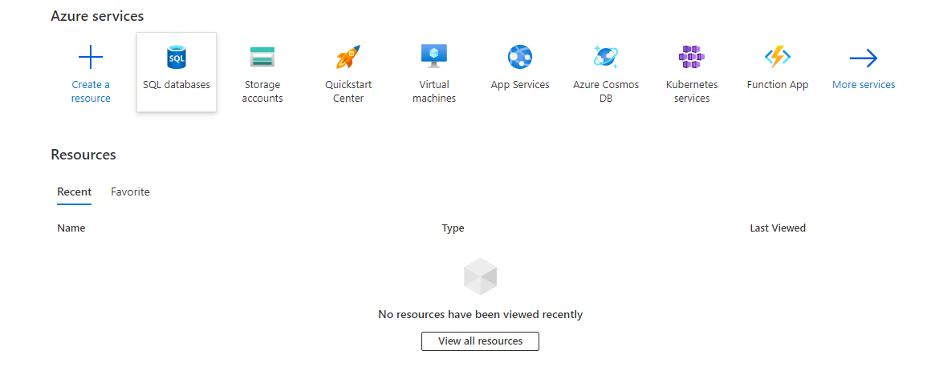

Figure : Created Azure Storage Account to Create SQL Database

* Creating the SQL database and database server by adding the required details like database name, server name and hosted region etc.
* Before tapping on create validated the added details later tapped on create

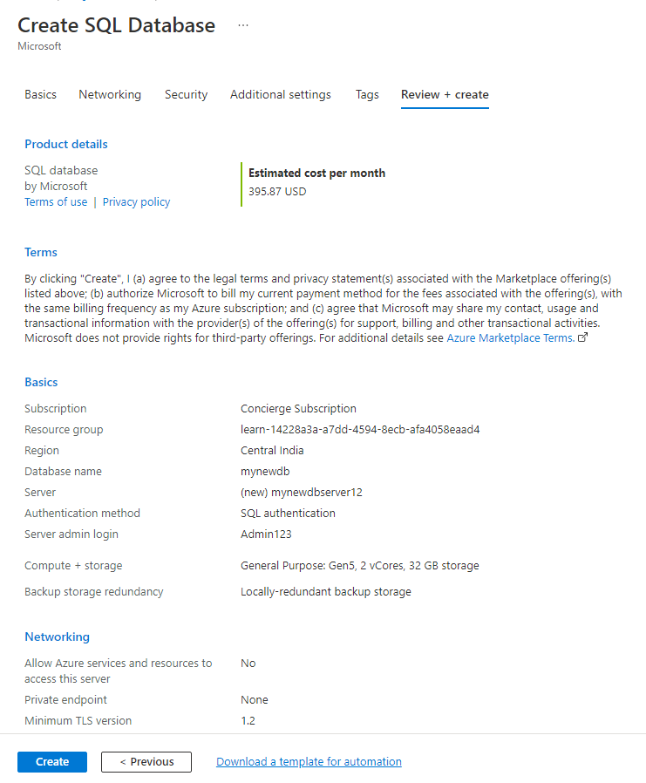

Figure : Creating SQL Database in Azure

* SQL database and database server got created.

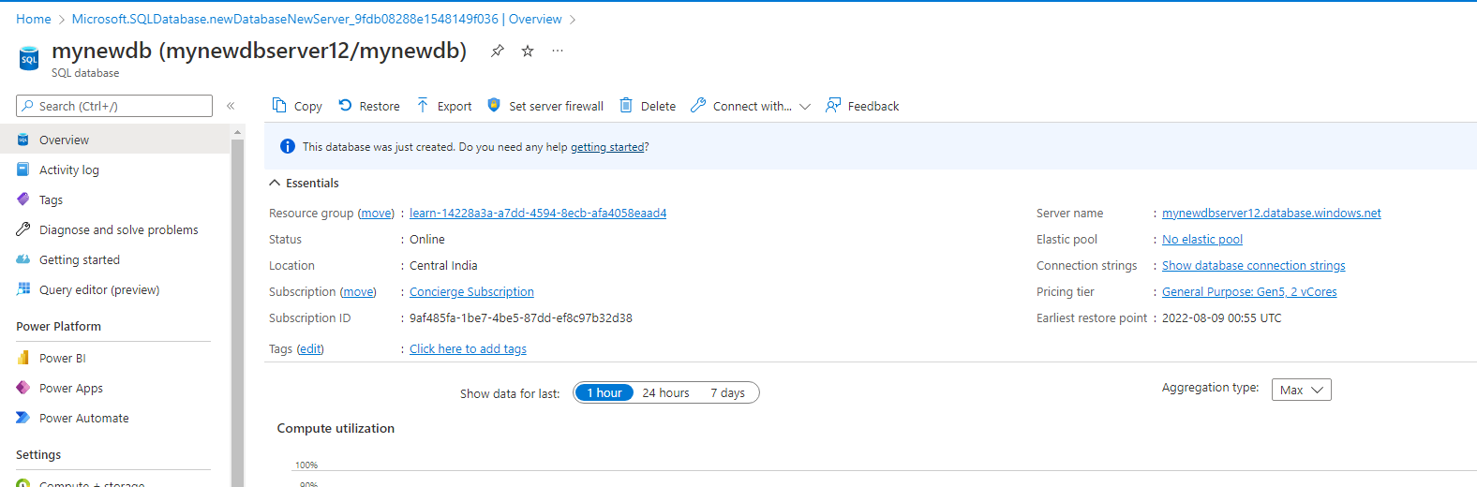

Figure : Created SQL database in Azure

* Set the firewall rules to allow the required internal connections to the database.

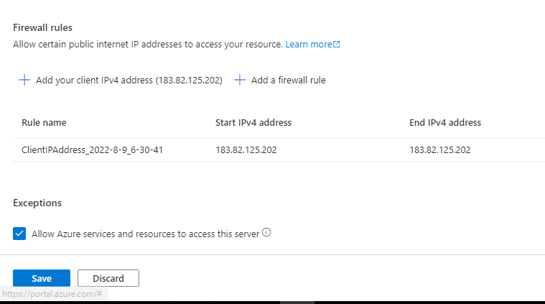

Figure : Set the firewall rule to the database

## Prerequisites

* With Visual Studio, I have connect Azure Functions Project to Azure SQL Database by using the Connected Services feature.
* The connected service functionality adds all the needed references and connection code to project, and modifies your configuration files appropriately.
* Opened Visual Studio and created **Azure Functions** Project

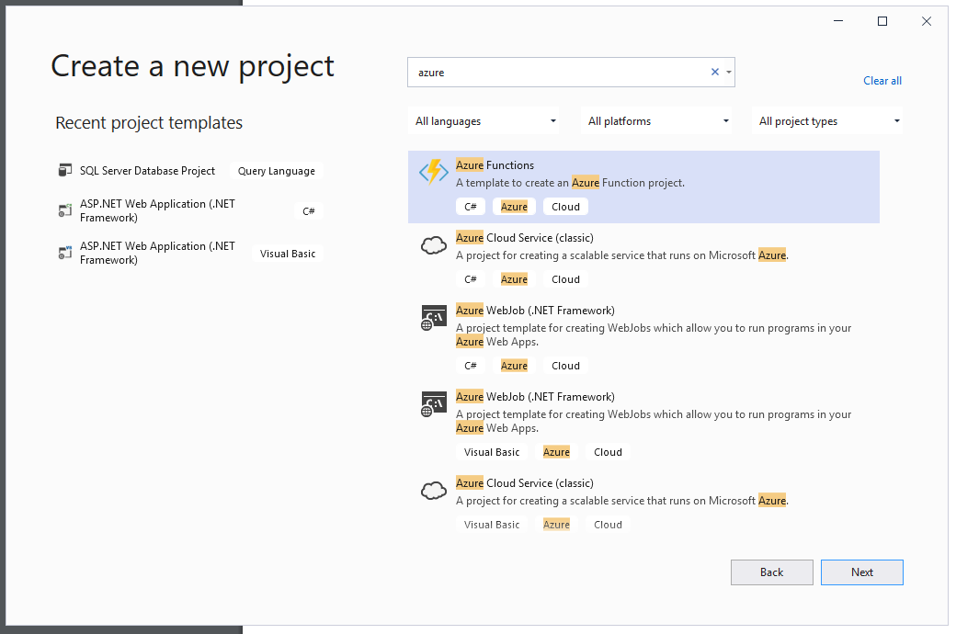

Figure : Creating Azure Functions project in Visual Studio

* Created project named as **NewFunctions**

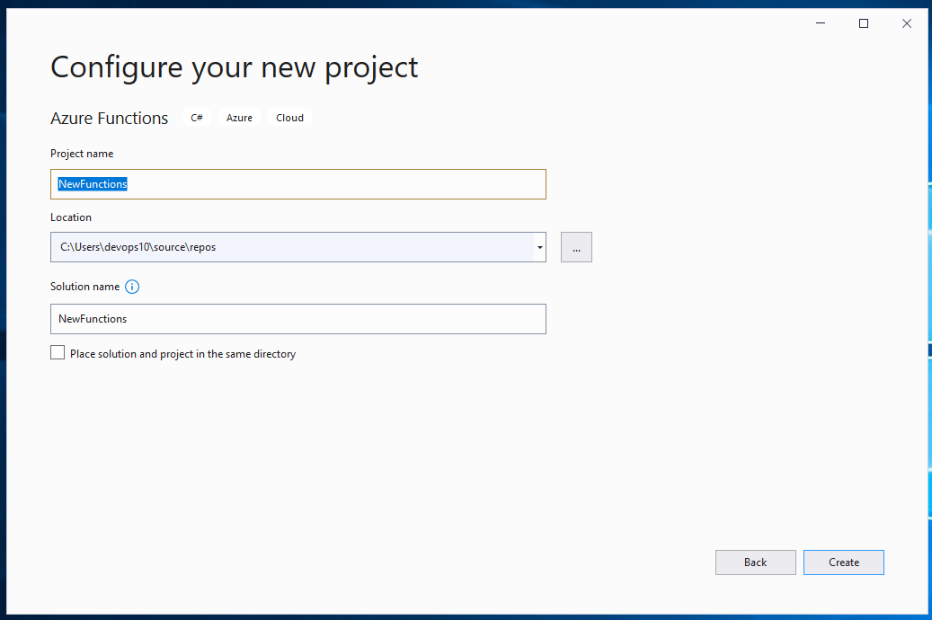

Figure : Assigning name to the Project

* Created Project **Dashboard**

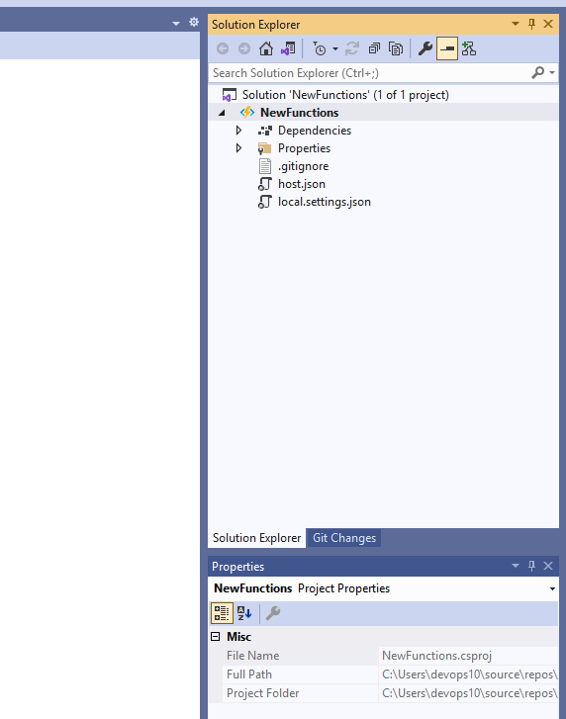

Figure : NewFunctions named project got created in VS

## Connect to Azure SQL Database using Connected Services

In Solution Explorer, right-click the **Connected Services** node and from the context menu, select **Add >> Connected Service**.

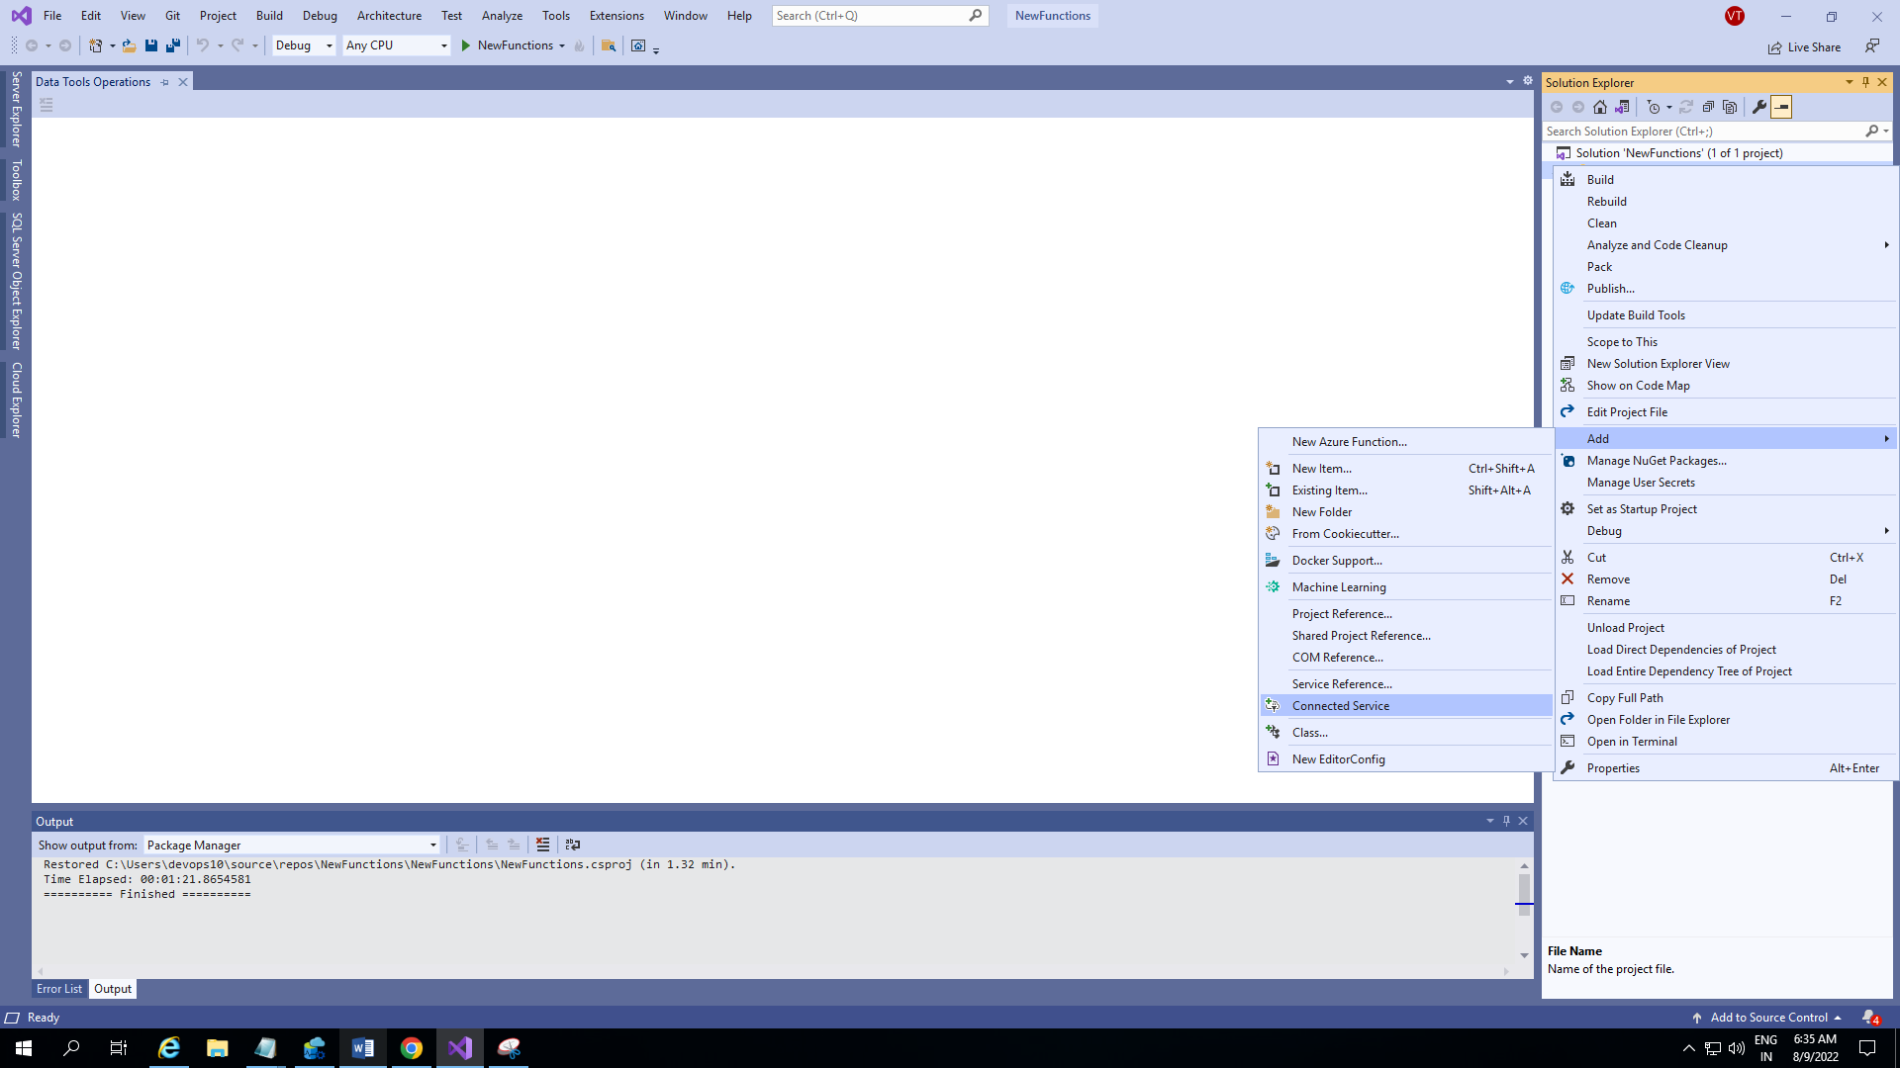

Figure : Adding connected Service to the Project

* In the **Connected Services** tab, select the **+** icon for **Service Dependencies**.

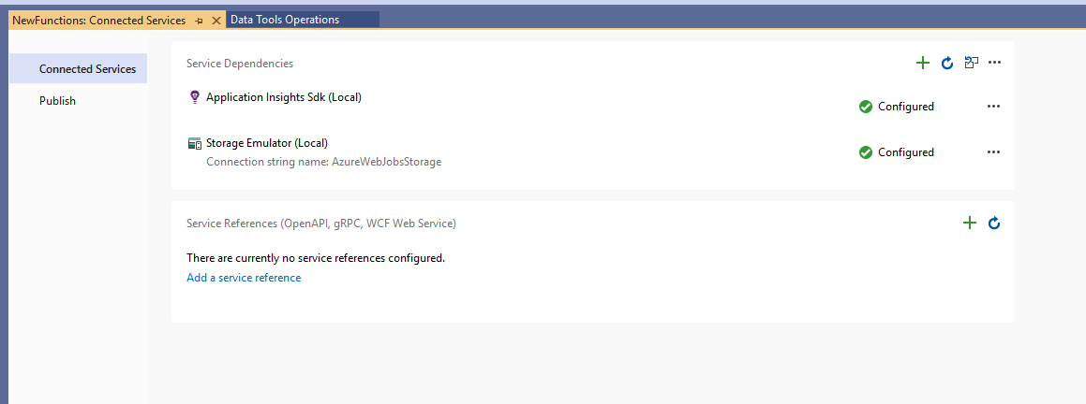

Figure : Adding existing database connection

* In the **Add Dependency** page, selected **Azure SQL Database** and tap **next**

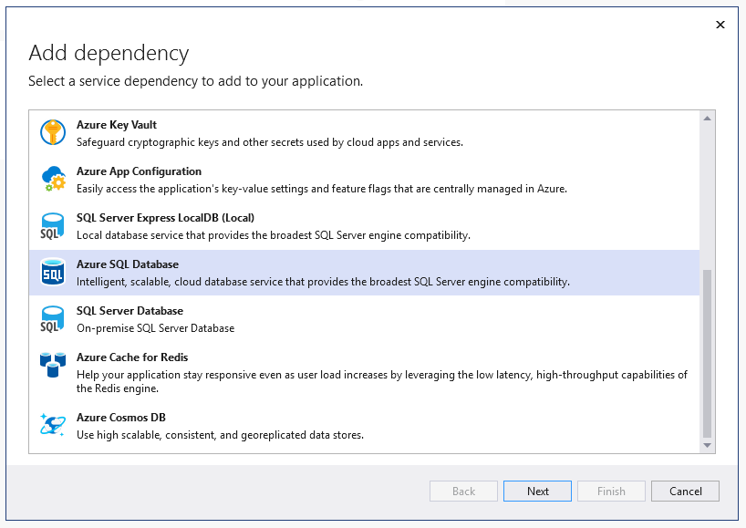

Figure : Adding Azure Database dependency

* In the **Configure Azure SQL Database** screen, Sign in to the existing **Azure account** and selected an existing **Azure SQL Database**, and select **Next**.

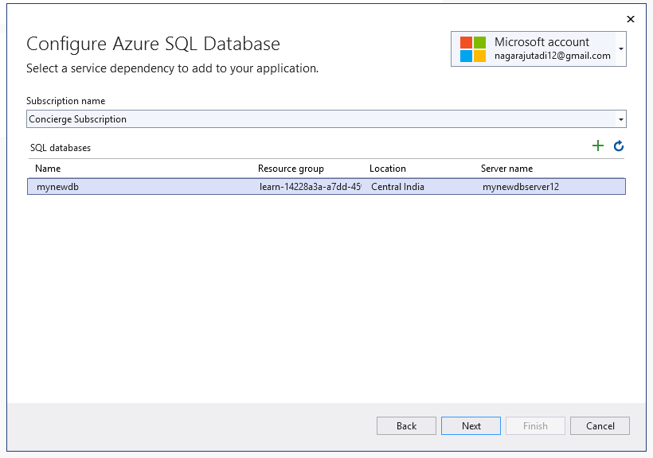

Figure : Sign in to the existing Azure account

* To create an Azure SQL Database from VS tap + from **Configure Azure SQL Database** screen.

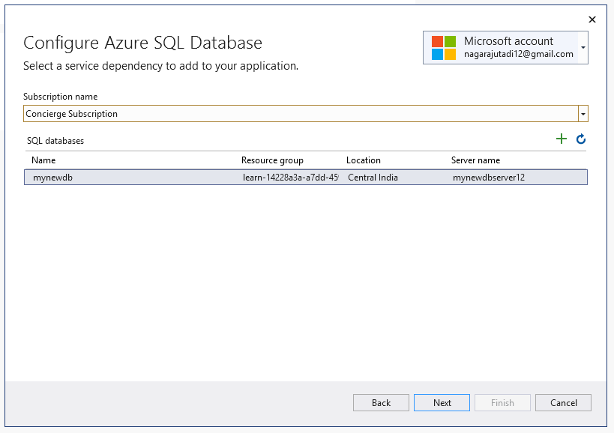

Figure : Displayed the existing database and created new database

* Fill out the **Azure SQL Database**: Create new screen, and select **Create**.

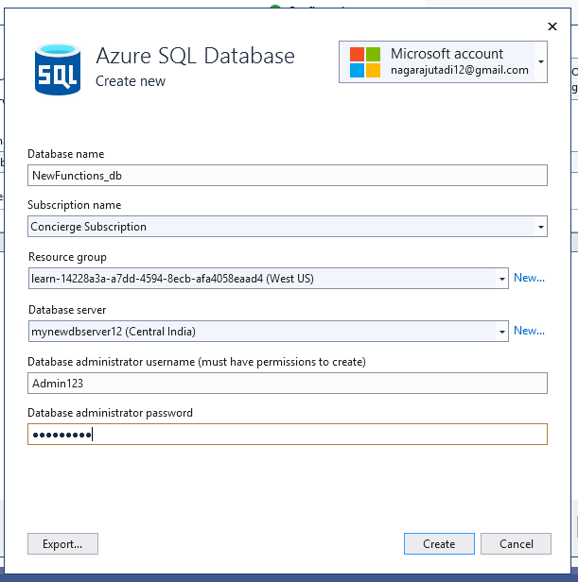

Figure : New database creation from visual studio

* When the **Configure Azure SQL Database** screen is displayed, the new database appears in the list. Select the new database in the list, and select **next.**

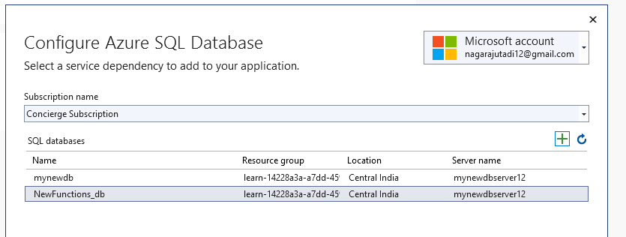

Figure : NewFunctions_db database got created

* Entered connection string name and given the Database connection credentials and tapped **Next**. String stored in a local secrets file.

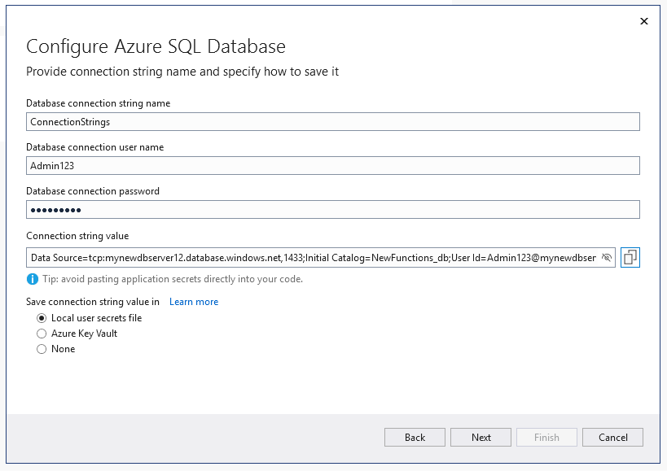

Figure : Configuring Database by adding database connection credentials

* The Summary of changes screen shows all the modifications that I made to project. Now tap on **Finish**.

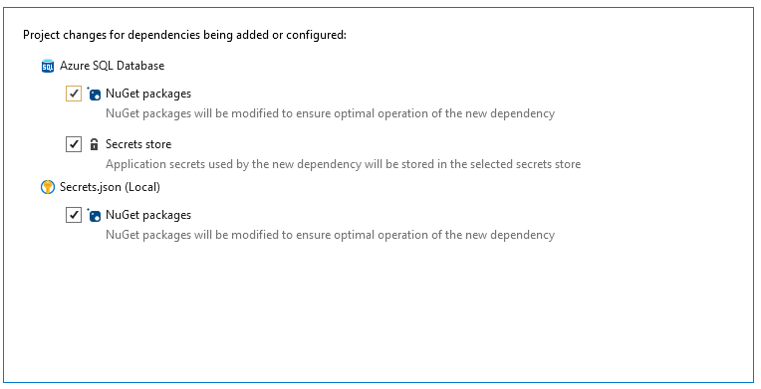

Figure : Displayed summary of changes

* Prompted to set a firewall rules, choose **Yes**

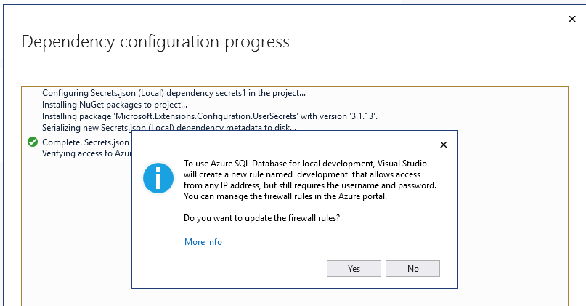

Figure : Given the permissions to update the firewall rule

* Dependency configuration is processed and configured

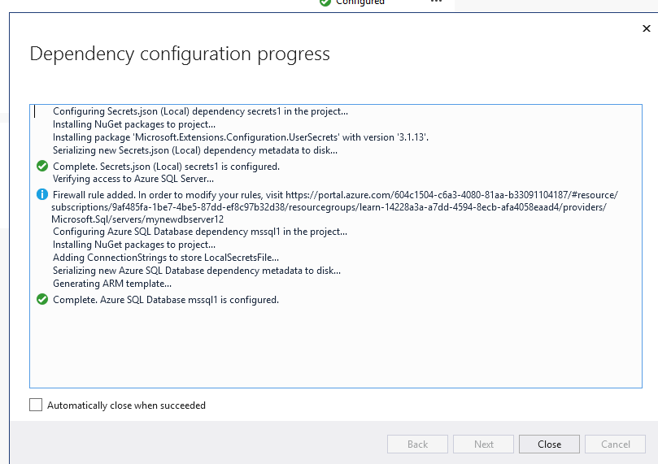

Figure : Azure database connection configuration status

* The connection appears under the **Service Dependencies** section of the **Connected Services** tab.

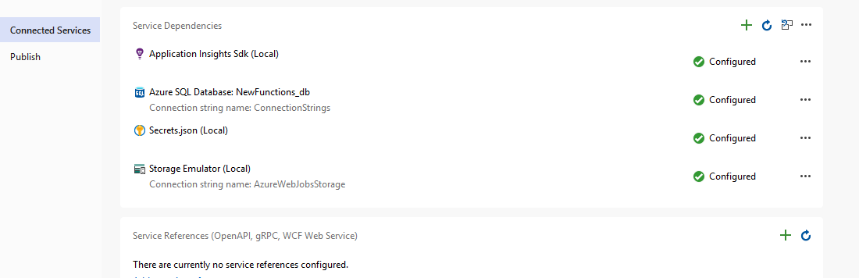

Figure : Database configured to the visual studio